EXPERIMENT 7
AIM :
CALCULATION AND VERIFICATION OF FREQUENCY DEVIATION AND MODULATION INDEX OF FM SIGNALS USING MATLAB SIMULATION

SOFTWARE REQUIRED:
MATLAB SIMULINK

PROGRAM:
Clc; clear; close all;
Fm=500;
Am=2;
Kf=1000;
Fc=10000;
Df=kf*Am;
Beta=df/fm;

Fprintf(‘Message Frequency (fm) = %d Hz\n’,fm);
Fprintf(‘Message Amplitude (Am) = %.2f V\n’,Am);
Fprintf(‘Frequency Sensitivity (kf) = %d Hz/V\n’,kf);
Fprintf(‘\nCALCULATED VALUES\n’);
Fprintf(‘Frequency Deviation = %d Hz\n’,df);
Fprintf(‘Modulation Index = %.2f\n’,beta);

Fprintf(‘\nVERIFICATION\n’);
Fprintf(‘Beta = df/fm = %d/%d = %.2f\n’,df,fm,df/fm);

If abs(beta-df/fm)<0.001
Disp(‘Verification Successful’);
Else
Disp(‘Verification Failed’);
End

T=0:1e-6:0.01;
M=Am*cos(2*pi*fm*t);
S=cos(2*pi*fc*t+beta*sin(2*pi*fm*t));

Figure;

Subplot(2,1,1);
Plot(t,m);
Title(‘Message Signal’);
Xlabel(‘Time (s)’);
Ylabel(‘Amplitude (V)’);
Grid on;

Subplot(2,1,2);
Plot(t,s);
Title(‘FM Signal’);
Xlabel(‘Time (s)’);
Ylabel(‘Amplitude (V)’);
Grid on;

OUTPUT:
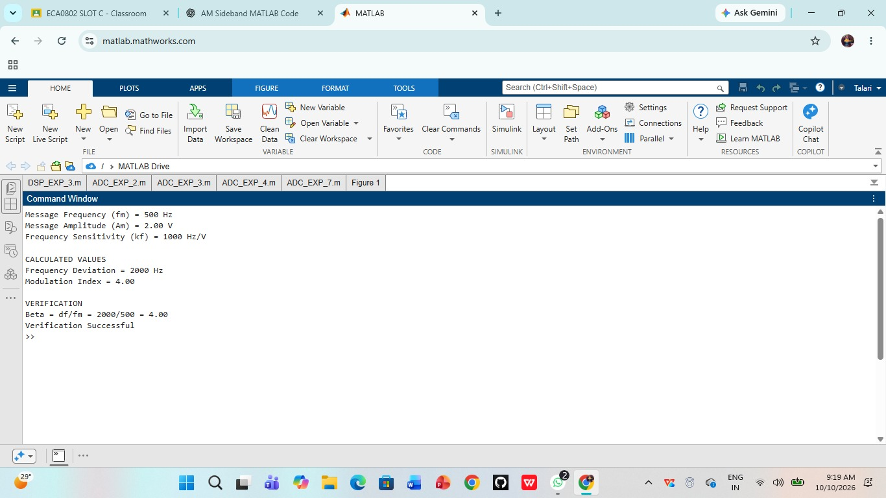

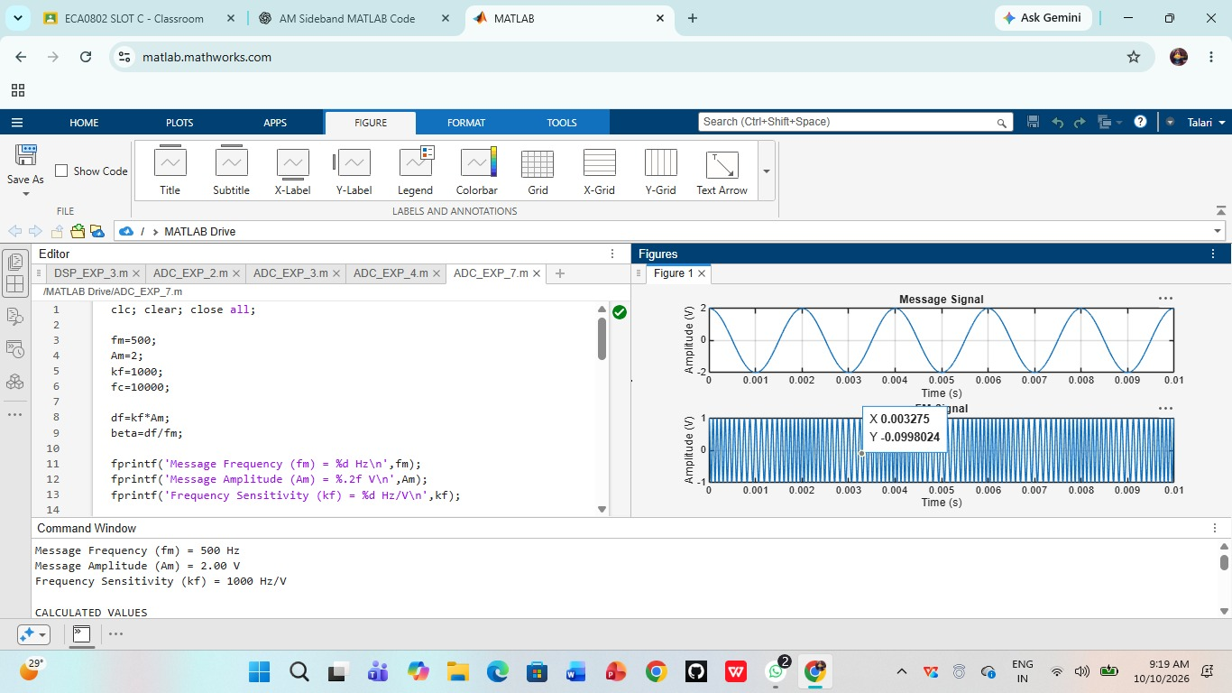

RESULT:
Thus, the frequency deviation and modulation index of the FM signal were calculated and verified successfully using MATLAB simulation. The message signal and FM signal waveforms were obtained.

